**How to find and replace text in PDF Document**

The Syncfusion Essential® PDF is a feature-rich and high-performance [**.NET PDF library**](https://www.syncfusion.com/document-processing/pdf-framework/net) used to create, read, and edit PDF documents programmatically without Adobe dependencies. Using this library, you can find and replace text from the existing PDF document with the help of our [**redaction**](https://www.syncfusion.com/document-processing/pdf-framework/net/pdf-library/redact) feature.

**Steps to find and replace text in a PDF programmatically**

1. Create a new console application project.A screenshot of a computer

   AI-generated content may be incorrect.
2. Install the **[Syncfusion.Pdf.Imaging.Net.Core](https://www.nuget.org/packages/Syncfusion.Pdf.Imaging.Net.Core" \t "_blank)** NuGet package as a reference to your .NET Core application from [**NuGet.org**](https://www.nuget.org/).

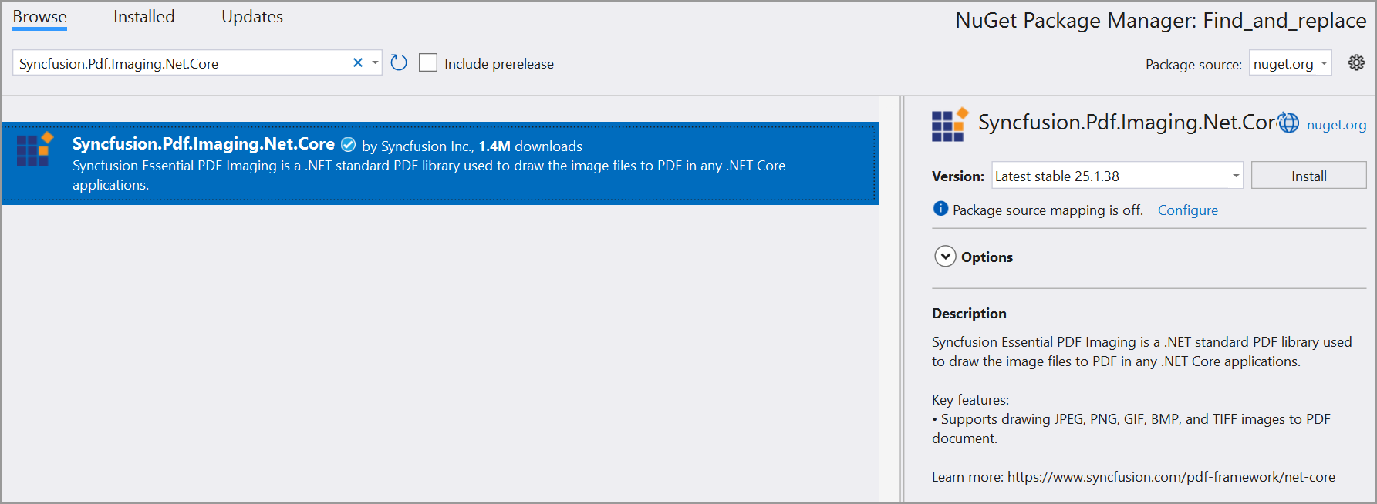

1. Include the following namespaces in the Program.cs file.

**C#**

using **Syncfusion**.Drawing;

using **Syncfusion**.Pdf.Graphics;

using **Syncfusion**.Pdf;

using **Syncfusion**.Pdf.Parsing;

using **Syncfusion**.Pdf.Redaction;

1. Use the following code sample in Program.cs to find and replace text from an existing PDF document.

**C#**

//Load the existing PDF document.

**FileStream** docStream = **new** **FileStream**(@"../../../Input.pdf", **FileMode**.Open, **FileAccess**.Read);

**PdfLoadedDocument** loadedDocument = **new** **PdfLoadedDocument**(docStream);

**Dictionary**<int, **List**<**RectangleF**>> matchedTextbounds = **new** **Dictionary**<int, **List**<**RectangleF**>>();

//Find the text using FindText method

loadedDocument.**FindText**("Fusce", out matchedTextbounds);

// Iterate through the matchedTextbounds dictionary.

foreach (**KeyValuePair**<int, **List**<**RectangleF**>> matchedText **in** matchedTextbounds)

{

//Create a font to draw the replacement text.

**PdfFont** font = **new** **PdfStandardFont**(**PdfFontFamily**.Helvetica, 9);

int pageIndex = matchedText.Key; // Get the page index

**List**<**RectangleF**> rectangles = matchedText.Value;

// Access the page using the page index

**PdfLoadedPage** lPage = loadedDocument.Pages[pageIndex] **as** **PdfLoadedPage**;

// Now, you can work with the page as needed.

**for** (int j = 0; j < rectangles.Count; j++)

{

//Create a PDF redaction and set the fill color as transparent.

**PdfRedaction** redaction = **new** **PdfRedaction**(rectangles[j], **Color**.Transparent);

//Draw the replacement text on the redaction appearance.

redaction.Appearance.Graphics.**DrawString**("Thats", font, **PdfBrushes**.Black, **PointF**.Empty);

lPage.**AddRedaction**(redaction);

}

}

//Apply redaction.

loadedDocument.**Redact**();

//Creating the stream object.

**MemoryStream** stream = **new** **MemoryStream**();

//Save a PDF document to a stream.

loadedDocument.**Save**(stream);

// Write the content of the memory stream to an output PDF file.

**File**.**WriteAllBytes**(@"../../../Output.pdf", stream.**ToArray**());

//Close the document.

loadedDocument.**Close**(true);

A complete working sample can be downloaded from [**Find\_and\_replace\_text\_in\_a\_PDF.zip**](https://www.syncfusion.com/downloads/support/directtrac/general/ze/Find_and_replace-1219138596.zip)

By executing the program, you will get the PDF document as follows.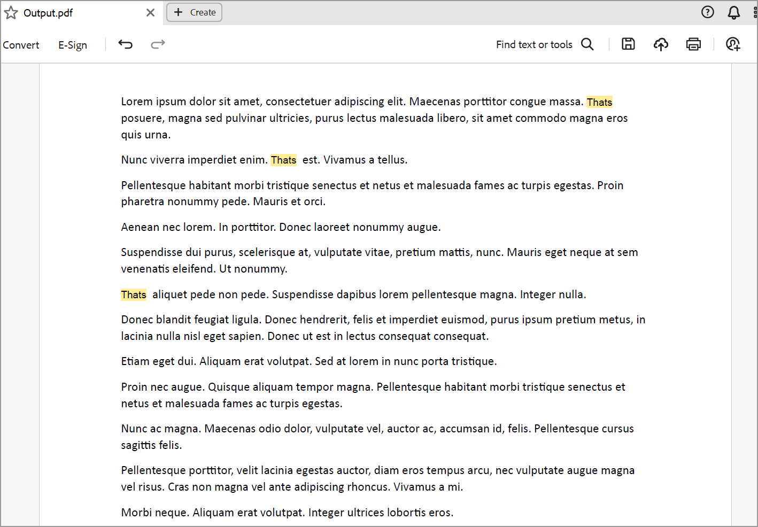

**Conclusion**  
I hope you enjoyed learning about how to find and replace text in PDF Document.

You can refer to our [**.NET PDF library**](https://www.syncfusion.com/document-processing/pdf-framework/net) page to know about its other groundbreaking feature representations and documentation, and how to quickly get started for configuration specifications. You can also explore our [**.NET PDF library Example**](https://www.syncfusion.com/demos/fileformats/pdf-library) to understand how to create and manipulate data.

For current customers, you can check out our [**ASP.NET**](http://asp.net/) Core Components from the [**License and Downloads**](https://www.syncfusion.com/sales/teamlicense) page. If you are new to Syncfusion®, you can try our 30-day [**free trial**](https://www.syncfusion.com/downloads/aspnetmvc-js2) to check out our other controls.

If you have any queries or require clarifications, please let us know in the comments section below. You can also contact us through our [**support forums**](https://www.syncfusion.com/forums), [**Direct-Trac**](https://support.syncfusion.com/create), or [**feedback portal**](https://www.syncfusion.com/feedback/aspnet-core?control=pdf). We are always happy to assist you!